2018/9/5

11:41 Can't finish GitHub sharing process

Successfully created project 'ideaproject' on GitHub, but initial commit failed:

\*\*\* Please tell me who you are.

Run

git config --global user.email "you@example.com"

git config --global user.name "Your Name"

to set your account's default identity.

Omit --global to set the identity only in this repository.

fatal: unable to auto-detect email address (got 'Administrator@lushao.(none)')

during executing git D:\Git\core\bin\git.exe -c core.quotepath=false -c log.showSignature=false commit -m "第一个git project" –

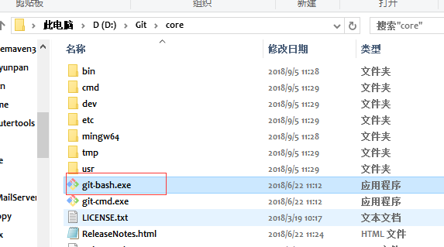

打开

1. git config --global user.email "you@example.com"
2. git config --global user.name "Your Name"
3. Administrator@lushao MINGW64 /
4. $ git config --global user.email "2538808545@qq.com"
5. Administrator@lushao MINGW64 /
6. $ git config --global user.name "duangdangding"

